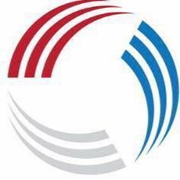
North Durham County Netball
Coaching Application Form 2023-2024
To apply for a coaching role in the North Durham County Netball Performance Pathway, please complete this application form.
Please outline how you meet the requirements of the post applied for (role descriptions are attached) in completing your application.
Only applications submitted on this form can be accepted (CVs cannot be accepted in place of the form but can be attached as supporting information).
The closing date for applications is Tuesday 13th June 2023
Completed applications should be sent to Joanna Makepeace, NDCNA Secretary at
secretaryndcna@gmail.com

Position Applied for (Please see advert for further details):
………………………………………………………………………………………………..

Name:
Address:
Email Address:
Telephone Number:

Netball Coaching Qualifications:

Please state all coaching qualifications and relevant workshops you have attended with approximate dates.

Coaching Skills and Approach
Please outline the skills you will bring to the role and your approach to coaching young athletes. If appointed, you will be asked to sign the attached EN Code of Conduct for Coaches of U18s.

Coaching Experience

Please outline your coaching experience relevant to the position you are applying for.

Please outline why you are applying for this post

Reference
Please provide the following information for your nominated referee.

Name:
Position (if relevant):
Contact number:
Email Address:
How long have you known this person?
And in what capacity?
Can we contact them?

