North Durham County are Recruiting…

We need top quality coaches to develop the future talent in our County

Want to work with inspiring, talented netball players in the North East?
Want to make a difference to netball development in YOUR County?
The following positions are available:
County Academy
North Durham County (U19) Head Coach – starting September 2019 @ The Beacon of Light - Thursdays 6.00-8.30
North Durham County (U19) Assistant Coach – starting September 2019 @ The Beacon of Light - Thursdays 6.00-8.30
North Durham County (U19) Development Coach - starting September 2019 @ The Beacon of Light - Thursdays 6.00-8.30

Head Coaches and assistant coaches must hold the following qualifications:-
Level 2/3 UKKCC, first aid, child protection, DBS
Development coaches must hold the following qualifications:-
Level 1 UKCC, DBS
Payments
Head Coach £25 PH expenses
Assistant Coach £20.00 PH expenses
Development Coaches £10.00 PH expenses
If you are interested in any of the positions above, please complete the application form and send to Performance Lead Julie Kimber at Julie.kimber@gateshead.ac.uk. For any other enquiries please contact Julie on 07801287877.
Closing date for applications is Tuesday 18th June at 4.00pm shortlisted applicants will be informed by Thursday 20th June and you will be invited for an informal interview and qualification check.
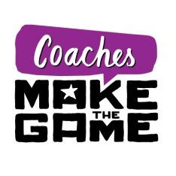
If appointed you need to be available to select at County trials on Saturday 29th June and Sunday 30th June 9.00-4.00 both days at the Beacon of Light.

